CS506 Programming for Computing
HOS04 – NumPy & pandas
08/07/2025 Reviewed by Ashwin Paturi
12/08/2025 Reviewed by Rajdeep Singh Golan
09/08/2026 Reviewed by Giridhar Dronamraju

School of Technology & Computing (STC)
City University of Seattle (CityU)

Before You Start
- Screenshots may be different from your environment.
- The directory path shown in screenshots may be different from yours.
- There might be subtle discrepancies along with the steps. Please use your best judgment while going through this cookbook-style tutorial to complete each step.
- Some steps may not be explained in detail. If you are not sure what to do:
- Consult the resources from the course.
- If you cannot solve the problem after a few tries (usually 15 -30 minutes), ask a TA for help.

Resources
- Data from Kaggle: https://www.kaggle.com/datasets
- NumPy Documentation: https://numpy.org/doc/stable/
- McIntire, G., Martin, B., & Washington, L. Pandas A Complete Introduction. Retrieved from https://www.learndatasci.com/tutorials/python-pandas-tutorial-complete-introduction-for-beginners/
- Pandas User Guide: https://pandas.pydata.org/pandas-docs/stable/user_guide/index.html
- Pandas Documentation: https://pandas.pydata.org/docs/user_guide/io.html?highlight=json#io-json-writer
- Pandas Documentation: https://pandas.pydata.org/docs/user_guide/index.html
- Pandas.qcut(): https://pandas.pydata.org/docs/reference/api/pandas.qcut.html
- Pandas.cut(): https://pandas.pydata.org/docs/reference/api/pandas.cut.html
- Pandas.transform(): https://pandas.pydata.org/docs/reference/api/pandas.DataFrame.transform.html?highlight=transform#pandas.DataFrame.transform
- Stanford University. (2020). CS231n: Convolutional Neural Networks for Visual Recognition: NumPy.

Learning Outcomes
- Section 1: Jupyter Notebook in Codespaces
- Section 2: NumPy
- Section 3: What is pandas?
- Section 4: Read and write with pandas
- Section 5: Data transformation
- Section 6: Data Discretization

Section 1: Jupyter Notebook in Codespaces
Follow instructions on how to install Jupyter Notebook on GitHub Codespaces here:
https://cityuseattle.github.io/docs/environment/codespaces_jupyter/

Learn and try Jupyter Notebook from JupyterLab: https://jupyter.org/try-jupyter/lab/

Section 2: NumPy, which stands for Numerical Python, is an open-source library for scientific computing in Python. It provides a high-performance multidimensional array object and tools for working with these arrays.
NumPy is memory efficient, meaning it can handle a vast amount of data more efficiently than any other library. We’ll cover the following in this module:
    - Datatypes
    - Arrays

Datatypes - The object defined in NumPy is an N-dimensional array type called ndarray, describing the collection of items of the same type. An element in an ndarray is an object of data type called dtype.
    - A dtype described in the following aspects:
      - Type of data (integer, float, Python object, etc.)
      - Size of the data (how many bytes is in e.g., the integer)
      - Byte order of the data (little-endian or big-endian)
      - Structured data type (e.g., describing an array item consisting of an integer and a float)

  - Create a new file called datatypes.ipynb and simply click on the file to open the notebook.
  - Type the following to see what NumPy says about data types. Run the selected cell to see the result for that cell.
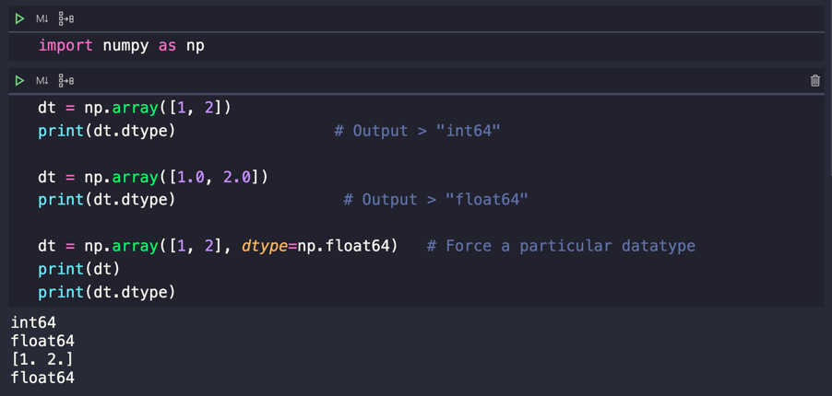

We can also define a structured data type. For example, we will define a data type named student with the three fields: name as a string, age as an integer, and points as a float.
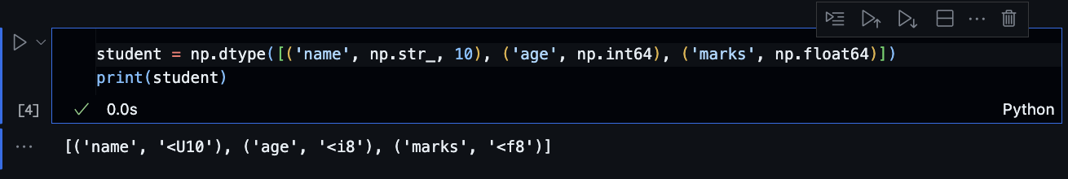

Let’s apply to an ndarray object.

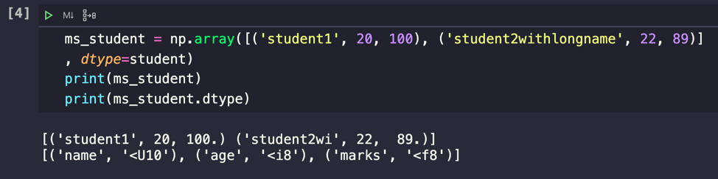

As you can see here, “student2withlongname” has exceeded the string length, and only a 10-character acceptance was defined.

Arrays - A numpy array is a grid of values, similar to Python lists, but all of the same type, and is indexed by a tuple of nonnegative integers. The rank and shape are the number of dimensions and a tuple of integers of the size of the array, respectively.
    - Create a new file called arrays.ipynb and simply click on the file to open the notebook.
    - Type the following to create numpy arrays. Accessing items in an array is similar to accessing elements in Python lists.

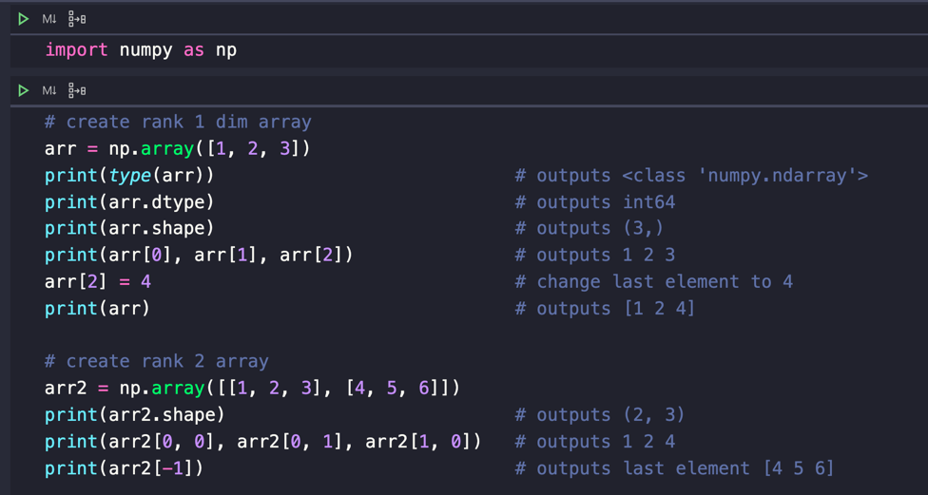
    - Stay in the same file, type the following functions from numpy to generate arrays differently. You will see how it can make your life easier with an array.

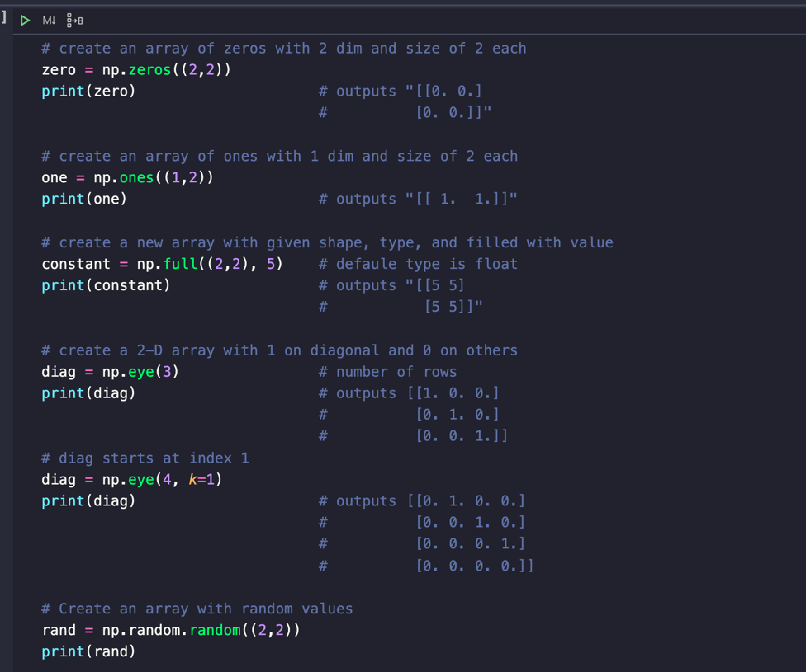

    - Indexing and slicing in NumPy arrays are similar to those in Python lists. Try the following in a new cell.

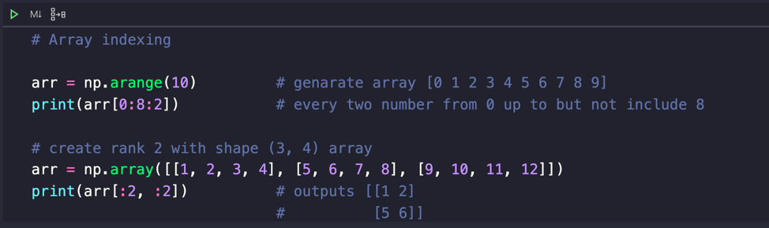

    - In NumPy, you can do integer indexing, which helps in selecting any arbitrary item in an array using the data from another array, like the example below. Add this to the new cell.

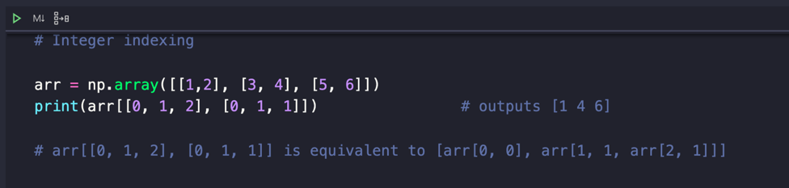

Section 3: What is pandas?
Pandas (derived from the word Panel Data – an Econometrics from Multidimensional data – Tutorialspoint) is a powerful, open-source Python library providing high-performance, easy-to-use data structures for data analysis, manipulation, and visualization.

Features of Pandas
      - Fast and efficient DataFrame object
      - Tools for loading data into in-memory data objects from different file formats.
      - Label-based slicing, indexing, and subsetting of large data sets.
      - Columns from a data structure can be deleted or inserted.
      - Group by data for aggregation and transformations.
      - High-performance merging and joining of data.

Core Components - The two primary data structures of pandas, Series and DataFrame.
    - Series – 1D labeled homogeneously-typed array
    - DataFrame – General 2D labeled, size-mutable tabular structure with potentially heterogeneously-typed columns.

A Series is essentially a column, and a DataFrame is a multi-dimensional table made up of a collection of Series.
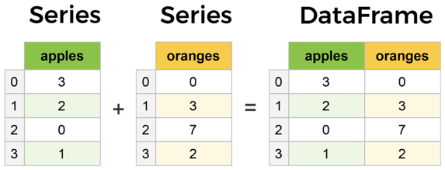

  - Create a new file called pandas_object.ipynb and simply click on the file to open the notebook.
  - Type the following into the file just created. Run the selected cell to see each result.

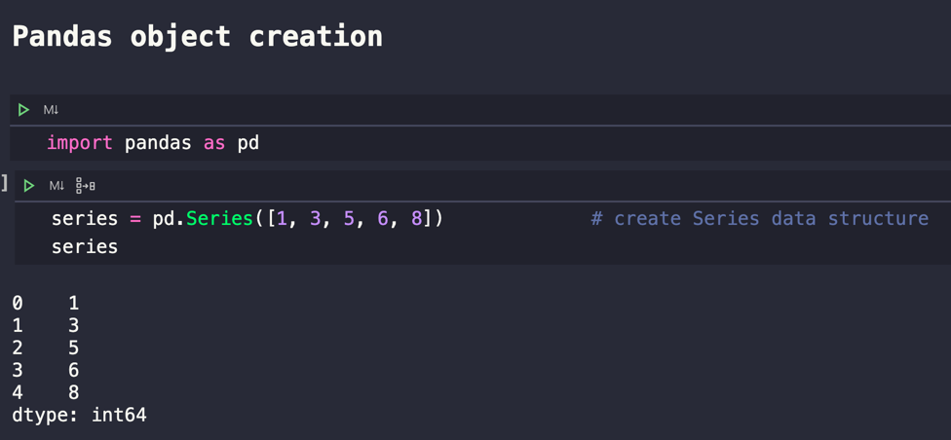
  - We just created a Series object with pandas, next we will create a DataFrame, which is a collection of Series.

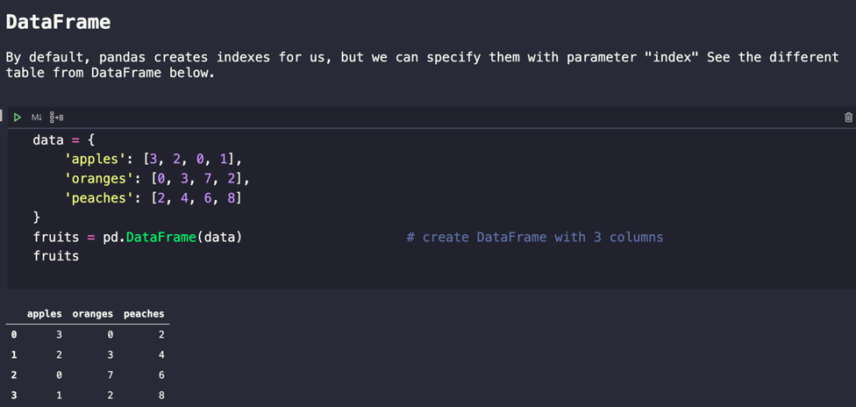

Each (key, value) item in data corresponds to a column in the resulting DataFrame.

  - The previous DataFrame, the index was given to the creation by default, but we can create our own labels as shown in the following example.

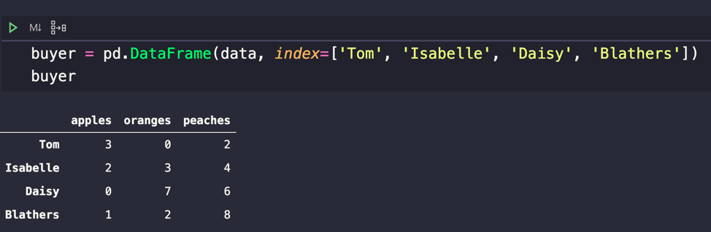

  - We gave string names as index replacement, so it is more convenient to locate the data by name. For example:
buyer.loc['Tom']
Output:
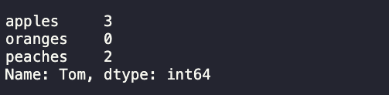

  - That’s the basic pandas; here is a lot more that pandas do. Learn more here:
https://pandas.pydata.org/pandas-docs/stable/user_guide/index.html

Section 4: Read and write with pandas
Pandas is a very powerful and popular framework for data analysis and manipulation. One of the most useful features of Pandas is the ability to read and write various types of files, including CSV. The Pandas I/O API is a set of top-level reader functions accessed like pd.read_csv() that generally return a Pandas object. More available readers and writers can be found here https://pandas.pydata.org/docs/user_guide/io.html

Common functionalities:
Format Type | Data Description | Reader | Writer
text | CSV | read_csv | to_csv
text | Fixed-Width Text File | read_fwf
text | JSON | read_json | to_json
text | HTML | read_html | to_html
text | Local clipboard | read_clipboard | to_clipboard
 | MS Excel | read_excel | to_excel

  - Verify that you have the file sales_data_sample.csv
  - Create a new file called reading_writing.ipynb and simply click on the file to open the notebook.
  - Type the following into the file just created. Run the selected cell to see each result.

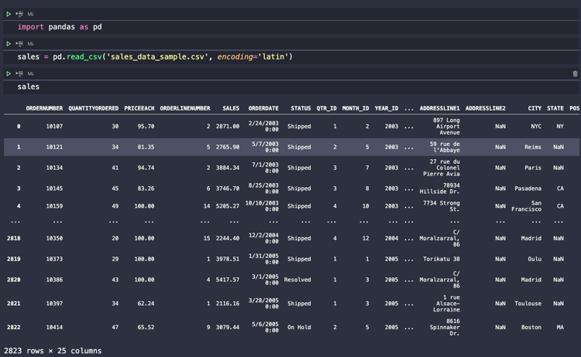

'latin-1' or 'iso-8859-1' is the simplest text encoding that maps the code points 0–255 to the bytes 0x0–0xff, which means that a string object that contains code points above U+00FF can’t be encoded with this codec. Doing so will raise a UnicodeEncodeError.

  - This data has 25 columns; you might not see the whole thing, but you still can see what they are with the columns DataFrame, like below.

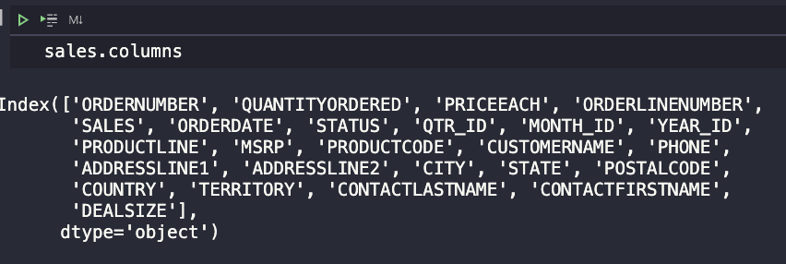

  - Now we will write a new CSV file with multiple columns selected by the indexing operator by passing a list of column names.

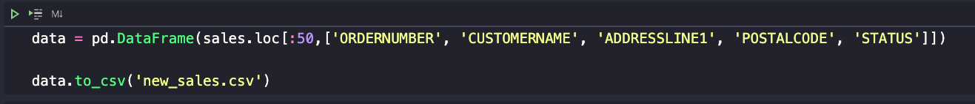

  - The Series and DataFrame objects have an instance method to_csv, which allows storing the contents of the object as a comma-separated-values file.
    - There are a couple of common exceptions that arise when doing selections with just the indexing operator.
    - If you misspell a word, you will get a KeyError
    - If you forgot to use a list to contain multiple columns, you would also get a KeyError
    - You just created a new CSV file named new_sales.csv with the to_csv method of DataFrame.
    - Check the contents of your new_sales.csv

Section 5: Data transformation
The process of changing the format, structure, or values of data to make the result more efficient and easier to understand. This involves converting data from one structure to another so you can integrate it with different applications.
With Pandas, we can perform a transformation. For this section, we will use the transform function.
- Create a new file named data_transformation.ipynb.
- Create a DataFrame with the following rows and columns.

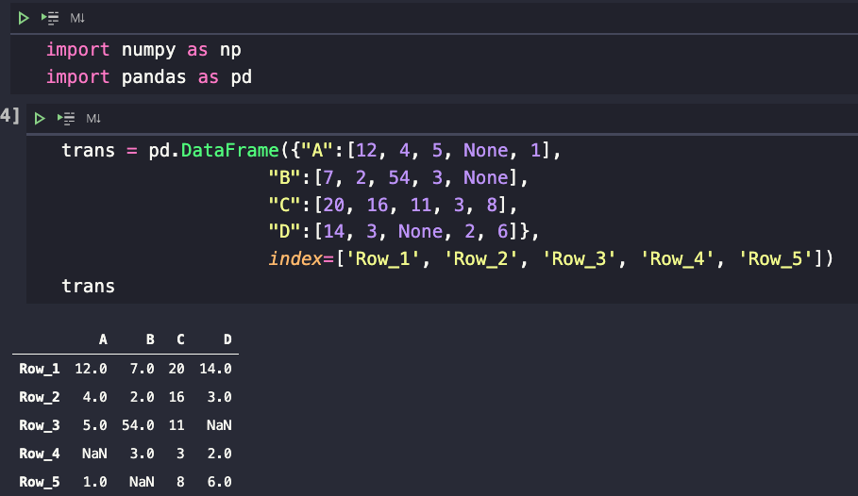

- Now we will use the transform() function to add 10 to each element of the data frame.
    - DataFrame.transform call func on self, producing a DataFrame with transformed values. The produced DataFrame will have the same axis length as self.

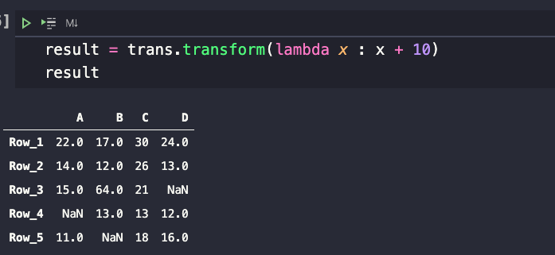
Notice that we used an anonymous function (lambda) to add 10 to each value. So, all non-empty values have been added successfully.

Section 6: Data Discretization
Defined as a process of converting continuous data attribute values into a finite set of intervals with minimal loss of information. For example, you have height data and want to discretize it to 0 and 1 intervals depending on whether the height is below or above a certain value.

  - Within the same file, create a numpy array with 10 random integers between 10 and 200.

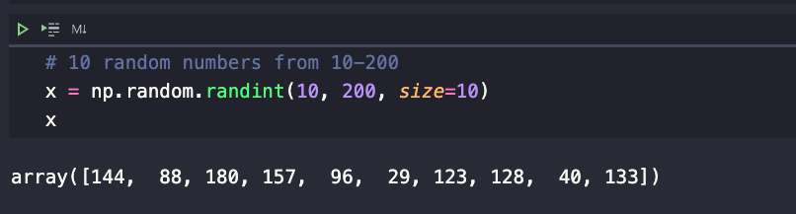

  - Numpy provides some of the functions you can perform discretization with, one of which is using digitize() for doing so.
  - In this step, we will discretize, where 50 is the threshold to divide the data into two categories: one less than 50 and one above 50.

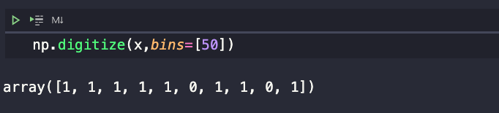

The bins argument is a list, allowing us to specify multiple binning or discretizing conditions. As you can see, there are only two numbers lower than 50 represented as 0. There are more than 50 represented as 1.
  - Let's say if we want to have three categories, how many values should we specify in the bins array? You got it, two values.

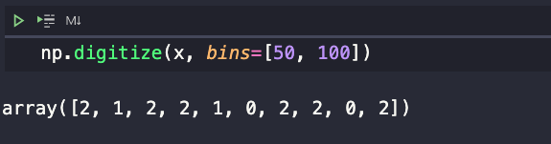

We have what we wanted. There are three categories here: 0, 1, and 2. Category 0 has a value of less than 50, category 1 has a value of less than 100, and category 2 has a value of more than 100.

  - Now let’s use a function from Pandas called cut() to discretize our data.
  - It does the same thing as what Numpy’s digitize() does, but the way it works is a bit different. Let’s first create a DataFrame with random numbers from the previous.

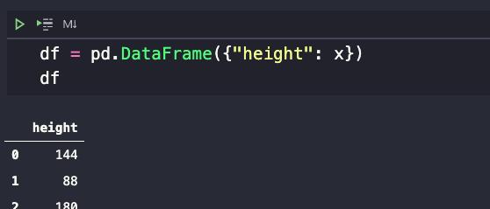

We created 10 values in height columns with index 0-9.

  - Categorize the height variable into four categories using Pandas cut function.

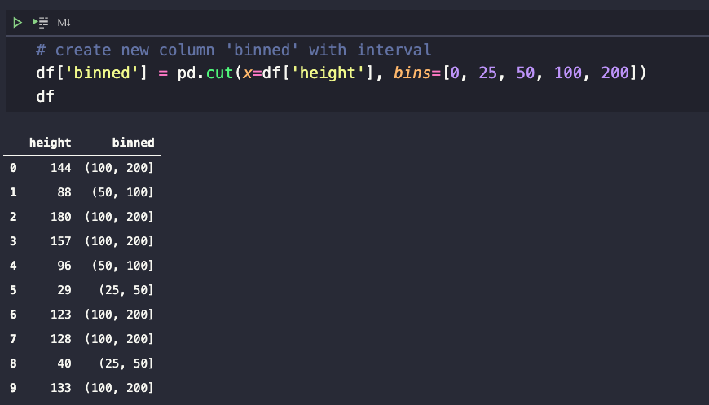

The height values between 0 and 25 are in one category, height between 25 and 50 are in the second category, 50-100 in the third category, and 100-200 are in the fourth category.

  - We can also label them as follows.
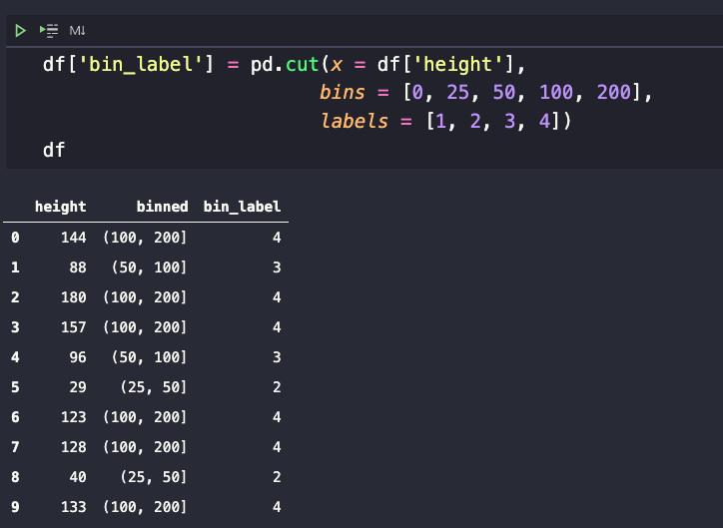

As my random data does not have values below 25, there is no category 1 in this example. Your data may be different. You can change labels to a string instead of a number.

  - Pandas also have another function called qcut(), which discretizes a variable into equal-sized buckets. You only need to tell the function the number of quantiles, and pandas will figure out how to bind that data.
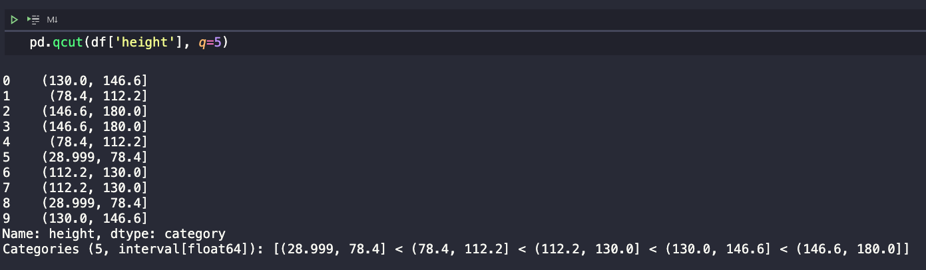

Notice that qcut discretized the data into equal-sized intervals, but the intervals are not equal. Binned into five groups with two members each. Unlike the cut function, which has no guarantee about the distribution of items in each bin, the interval is pretty much the same for all bins.

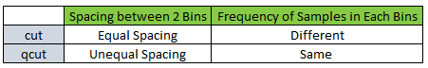

  - Let’s look at a familiar example below of how to use discretize with data.
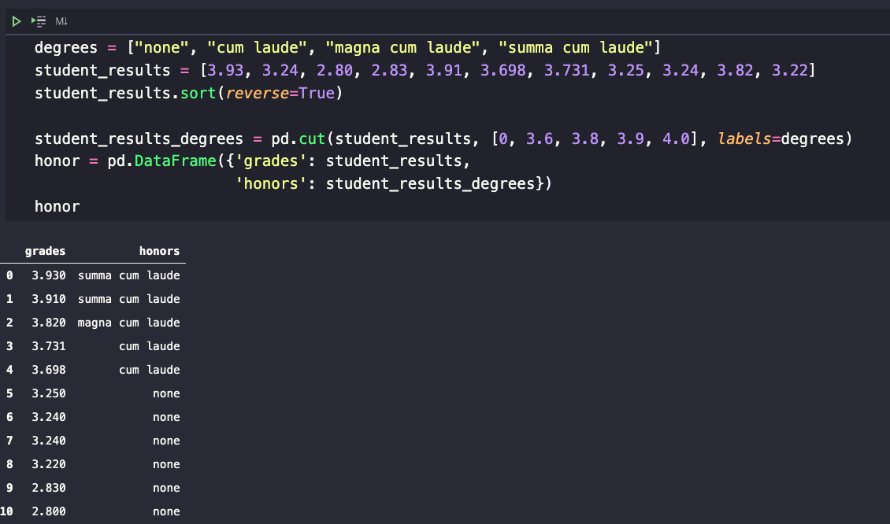

Line number 3, we sorted for easier viewing in each category. We categorized the grades into their respective categories. Then, we put the data into a DataFrame.
  - If you are a visual person, you need to see the chart. You can do that with a basic plotting provided by pandas, like the image below.
  - We will do a bar plot based on the number of students in each group.

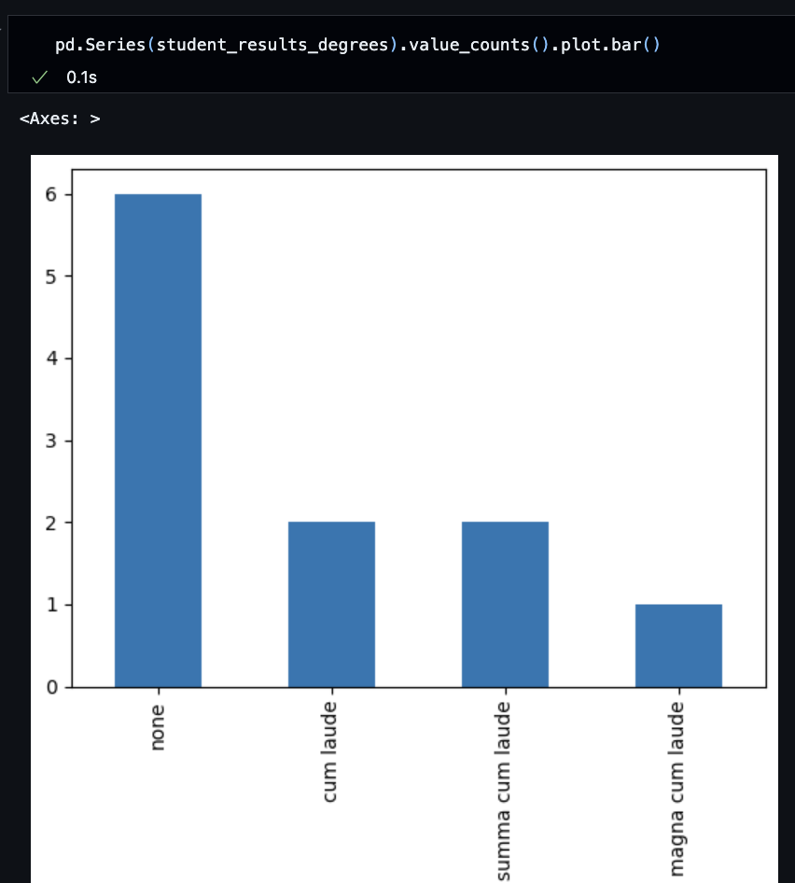
  - If you want to see what value_counts() does, remove “.plot.bar()”

Push your work to GitHub Codespaces:
Follow instructions here: https://cityuseattle.github.io/

